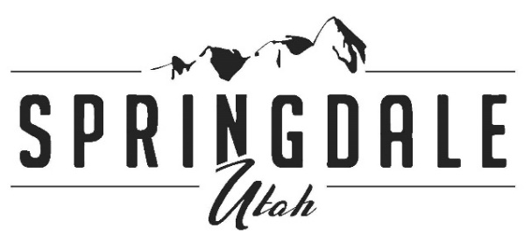

**118 Lion Blvd. PO Box 187 Springdale UT 84767 435-772-3434 fax 435-772-3952**

July 19, 2023

Congressman Blake Moore

1131 Longworth House Office Building

Washington, D.C.

Re:  LODGE Act

Dear Congressman Moore,

The Town of Springdale, Utah, supports your Lodging Options Developed for Government Employees (LODGE) Act.

As the gateway community to Zion National Park, Springdale has experienced an exponential increase in the number of visitors.  There were over 5 million visitors to Zion in 2021 and 4.7 million visitors in 2022.  This has put increased pressure on our businesses (especially hotels and restaurants) at a time when it is difficult to hire and retain employees.  Factors such as lack of housing, cost of gasoline, growth in Washington County, and limited access to our area on a 2-lane highway (SR-9) are all impacting our businesses’ staffing levels.  Many of our restaurants are reducing their hours and closing for two days per week, resulting in long waits for meals.

Zion National Park is understaffed for many of the same reasons. There are anecdotal stories of potential employees accepting jobs with Zion National Park, only to renege when they can't find housing in the area. They are competing with the 1000+ employees working in the Town of Springdale. The LODGE Act would provide a tool to begin to solve this housing problem, supplementing the Workforce Housing Overlay Zone ordinance passed by our Town Council in June 2023.

Thank you for your leadership and service.

Sincerely,

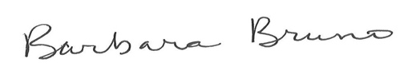

Barbara Bruno

Mayor, Town of Springdale

801-243-5861

bbruno@springdale.utah.gov